Name: Zulqarnain hasssan
Class & Section: BSSE-VI-Afternoon
Roll number: SP21379
Assigned Design 1: Atiqa Saeed, Yale School of Art
Design Link 1: https://www.figma.com/design/X90L37G7SlrlidhpysvXgX/yale-school-of-art-design?node-id=0-1&t=oYaTI7G0Rlr2YsfY-1
Assigned Design 2:
Design Link 2:
Assessment: Use/apply think aloud protocol, observational study, task analysis. Visual Design Elements, Color, Typography, Layout, Visual Hierarchy, Contrast and Visual Balance, Designing for Accessibility, Navigation, Readability.

1. Visual Design (According to Trend)
Problems:
- The school name is not looking well placed.
- The design is clean but lacks uniqueness or modern interactive elements.
- The event calendar section looks slightly outdated and could benefit from a more engaging UI.
- Some sections feel crowded, affecting the aesthetic appeal.
- Icons are not visible and text color is also mixing with the background color (on the calendar).
Recommendations:
- School name should be placed below the menu bar over the hero image.
- Introduce more white space to give a modern feel.
- Use subtle animations or hover effects for interactivity.
- Improve the event calendar UI with better spacing and visual elements.
- Use clear and visible icons.
Screenshots:
1:
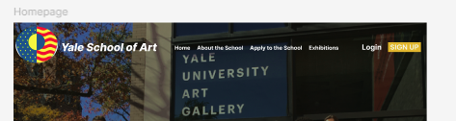
2:
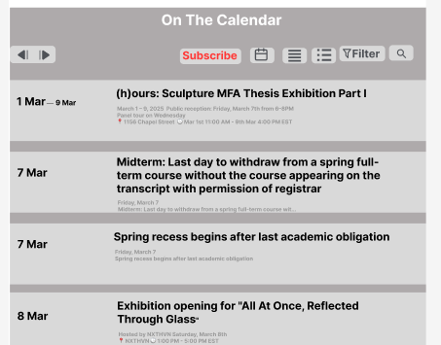
3:
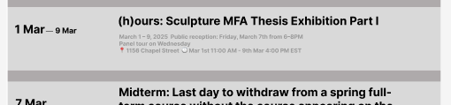

2. Clarity & Conciseness
Problems:
- Event descriptions are somewhat packed together, reducing clarity.
- Subscribe buttons don’t clearly indicate their purpose.
- Icons not properly align.
Recommendations:
- Space out event descriptions for better readability.
- Use tooltips or short labels to explain unclear buttons.
- Add icons where needed to improve understanding.
Screenshots:
1:
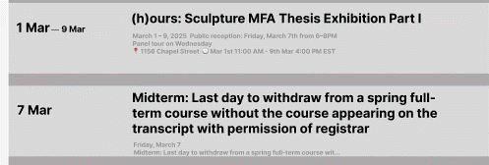
2:
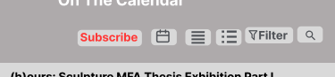

3. Learnability
Problems:
- The navigation bar follows a standard pattern but lacks clear visual feedback when hovering or selecting a page.
- Some buttons could be more intuitive (e.g., “Subscribe” in the calendar).
Recommendations:
- Implement hover effects to show interactivity.
- Use color or underline effects for selected menu items.
- Provide clear explanations or labels for buttons.
Screenshots:
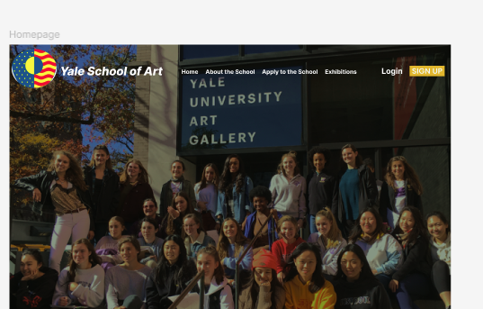

4. Navigation
Problems:
- The menu bar is not functional and lacks a strong visual hierarchy.
- No clear breadcrumbs or indicators showing the current page.
Recommendations:
- Highlight the active menu item for better orientation.
- Consider adding breadcrumbs for deeper navigation.
- Ensure all links are clearly visible and accessible.

5. Grids
Problems:
- The page follows a grid structure, but some sections feel misaligned.
- The event list looks cramped, reducing readability.
Recommendations:
- Maintain a consistent grid for spacing across sections.
- Adjust padding and margins to balance content.
- Ensure event listings have uniform spacing.
Screenshots:

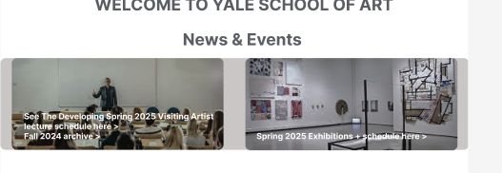

6. Alignments
Problems:
- Some text elements and buttons seem slightly off in alignment.
- The event section could be better spaced for consistency.
Recommendations:
- Align text elements properly within their containers.
- Use a consistent margin and padding system.
- Ensure the event list follows a proper grid layout.
Screenshots:
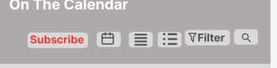

7. Color Scheme
Problems:
- The color scheme is mostly neutral but lacks contrast in some areas.
- The “Subscribe” button doesn’t stand out enough.
Recommendations:
- Increase contrast in areas where text blends with the background.
- Use a more vibrant color for the call-to-action buttons.
- Ensure accessibility by checking color contrast ratios.

8. Typography Analysis
Problems:
- Some text sizes are inconsistent, making the design feel unpolished.
- Event details appear cramped, reducing readability.
- Recommendations:
- Use a consistent font hierarchy (headings, subheadings, body text).
- spacing in the event section for better legibility.
- text is not too small for accessibility purposes.

9. Readability Analysis
Problems:
- Text inside buttons and event details are slightly small.
- Some sections feel cluttered, making it harder to read at a glance.
Recommendations:
- Increase font size for event descriptions.
- Space out text elements to reduce clutter
- Ensure sufficient contrast between text and background.

10. Major Issues
- Cluttered event section affects readability and usability.
- Navigation lacks clear indicators for the active page.
- Low contrast buttons make some interactive elements hard to notice.
- Inconsistent alignment and spacing create a slightly unpolished look.

11. Recommendations
- Improve contrast and color choices for accessibility.
- out event listings for better readability.
- Use proper text alignment and consistent font sizes.
- navigation items to enhance user orientation.
- Improve the visual appeal of the calendar section.

12. Conclusion
The website is well-structured with a clear focus on usability. However, minor design issues such as spacing, contrast, and readability affect the overall experience. Implementing the above recommendations will enhance clarity, engagement, and accessibility, making the site more user-friendly and visually appealing.

